**A**

**The First Term Test**

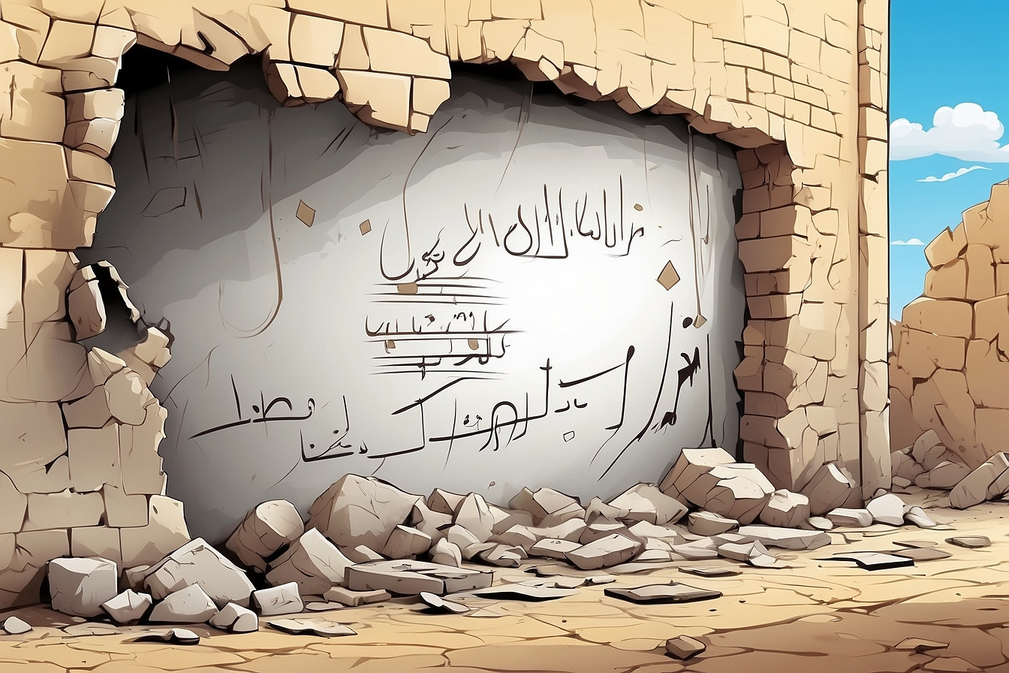

**Full Name :……………….**

**Class :4MS……………….**



Harun al-Rashid was born on March 17th, 763 in Rey, near Tahran, Iran. He was the son of al-Mahdi, **who** the third Abbasid Caliph (ruled 775 – 786). Most of his time was dedicated to mastering Hadith and Quran. In addition, he underwent advanced physical education as a future mujahid and therefore he practised swordplay, archery and learnt the art of war. At the age of 18, a few years before becoming Caliph, Harun married his cousin Amat al-Aziz (nicknamed Zoubaida).

Harun al-Rachid became Caliph in his early twenties in 786. Under **his** rule, Baghdad flourished into the most magnificent city of its period. Because of the ‘Thousand and One Nights’ tales, Harun al-Rashid was considered a legendary figure obscuring his true historic personality. He died in Tus, Iran on March 24th, 809.

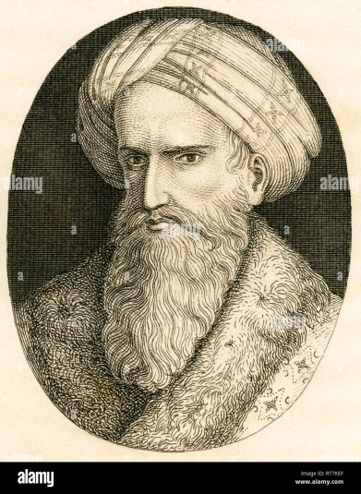

**Part one**

A/Reading Comprehension

Activity 01: Read the text and answer the questions (02pts)

1. What or who do the words in bold type refer to:

**Who** 🡺 ………………………… **His** 🡺………………………………..

1. When did Harun al-Rashid became Caliph?

………………………………………………………………………………….

Activity 02: Read the text again and fill in the table. (03pts)

|  |  |  |  |  |  |
| --- | --- | --- | --- | --- | --- |
| Real name | Occupation | Date of birth | Place of birth | Date of death | Place of death |
|  |  |  |  |  |  |

Activity 03: Find in the text : (02pts)

Synonyms to:

Amazing = ……………………….. (§2) viewed = …………..………… (§ 2)

Opposites to:

Later ≠……………………….. (§2) False ≠ ………………………. (§2)

B/Mastery of Language

Activity 01: Finish the following table: (03pts)

|  |  |
| --- | --- |
| Adjectives | Comparative of superiority |
| - Big  - ………………………………  - Expensive | - ………………………….  - Easier than  - ......................................... |

Activity 02: Fill in the gaps with the appropriate connector (cause/result): (02pts)

1. Laarbi Ben Mhidi was killed ………………………………..he refused to surrender.
2. Mark wanted to see the Eiffel Tower, ……………………………..he travelled to Paris.

Activity 03: Circle the silent letter in the following words: (02pts)

Often - Lamb - Half - Write

**Part two**

Situation of Integration: (06pts)

***Djamila Bouhired is one of the greatest figures in Algerian history.***

Your teacher asked to write a short biography about this outstanding figure to post it on your school blog. Use the information bellow to help you.

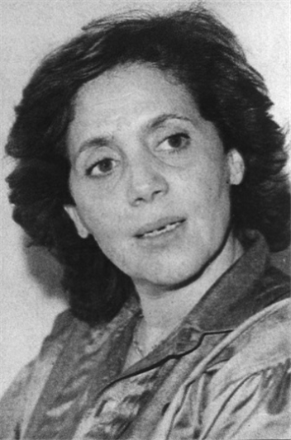 **Full name**: Djamila Bouhired

**Date and place of birth:** June 1935- Algiers - Algeria

**Family:** Middle class family, Tunisian mother, Algerian father

**Occupation:** Algerian militant, nationalist

**Life events:**

* (to join) the Algerian National Front (FLN)

while ( to be) a student

* (to capture) by the French army (April 1957)
* (to face) torture for 17 days in front of her mother

but (not/ to stop) fighting for her country

* (to bomb) a café killing 11 French people (1957)
* A film by the Egyptian director ‘Yusuf Chahin’

(to tell) her story (1958)

………………………………………………………………………………………………………………………………………………………………………………………………………………………………………………………………………………………………………………………………………………………………………………………………………………………………………………………………………………………………………………………………………………………………………………………………………………………………………………………………………………………………………………………………………………………………………………………………………………………………………………………………………………………………………………………………………………………………………………………………